Cites references throughout using appropriate APA format. Provides references at end. Consistently uses grammatically-correct posts with little or no misspellings. Provide references at end. Please respond in depth and very detailed. At least 2 paragraphs or however long it takes to respond to questions. If possible use the book Edelman, C. L.& Mandle, C.L. (2018). Health Promotion throughout the Lifespan, 9th ed, Mosby/Elsevier, ISBN#: 978-0-323-56910-1.

- Choose a health-related issue for individuals that is addressed on the Healthy People 2020 list; i.e. physical activity for adolescents, cigarette use by adults. Discuss health promotion activities associated with the issue that you identified with an aim at illness prevention. Healthy People 2020 link is in the course and here as well. http://healthypeople.gov/2020/default.aspx

The federal government developed Healthy People 2020 as its prevention agenda determined to build a healthier nation. This program guides the public towards objectives that will help them identify the most significant avoidable threats to their health and wellness. Moreover, the main objective of this program is to reduce these threats to an individual, and in the long run, will help envision a nation that is free from illnesses and diseases (Centers for Disease Control and Prevention, 2019). From this list mentioned, the tobacco use caught my interest. It is apprehended as the single most preventable cause of disease in the society, yet, more deaths occur that are related to it. From instance, Healthy People 2020 (2014) reveals that there is a 12 percent increase in cigarette smoking among adults from the 2008-2012 period.

As implied, tobacco use can cause serious health disease that could result in death. In order to reduce the number of deaths, the government’s program established promotion activities that aim for tobacco use reduction in the community. Among the activities include raising awareness from preventing oneself on the initiation of cigarette, most especially youths and adults. Additionally, Healthy People 2020 (2017) attempts to educate smokers to quit as early as they can in order for them to become healthy and then reduce exposure to secondhand smoke. The CDC also provided budget structure to implement tobacco use core program components, which include the State and Community Interventions, Mass-Reach Health Communication Interventions, Surveillance and Evaluation, and Cessation Interventions. Overall, these programs intend to attain high quality and longer lives for the public to be free of preventable diseases. Lastly, Healthy People 2020 aims to create a social and physical environment that people could benefit from.

References

Centers for Disease Control and Prevention. (2019). Division for heart disease and stroke prevention: Healthy people 2020. In cdc.gov. Retrieved from https://www.cdc.gov/dhdsp/hp2020.htm

Healthy People 2020. (2017). Tobacco use topic area. In cdc.gov. Retrieved fromhttps://www.cdc.gov/tobacco/basic_information/healthy_people/toolkit/pdfs/hp2020-slides-031717.pdf

- Look at the Healthy People 2020 Selected Examples of
National Health-Promotion and Disease-Prevention Objectives for families in
Edelman & Mandle (your textbook) on page 155; Box 7-3.
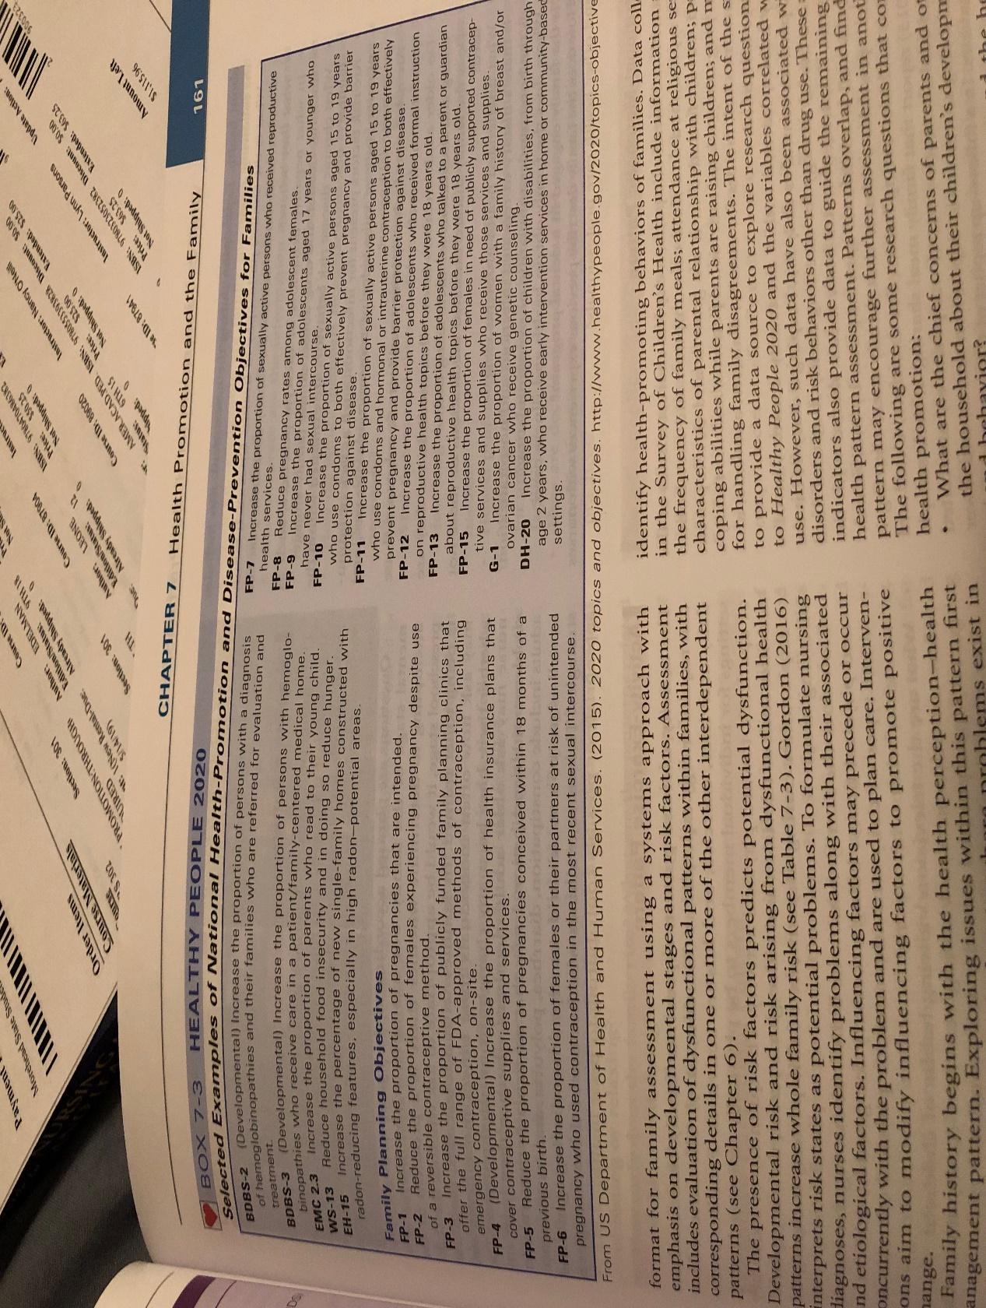
(BOX 7-3 ABOVE)

Choose a health related issue for families that is addressed on the Healthy
People 2020 list; i.e. reduce proportion of person’s binge drinking of
alcoholic beverages, reduce portion of adult obesity. Discuss health promotion
activities associated with the issue that you identified with an aim at illness
prevention.

Healthy People 2020 link is in the course and here as well.
www.healthypeople.gov/2020/topicsobjectives2020/default.aspx

The main objective of Healthy People 2020 (2017) is to give a structure for prevention for the people in the United States. The health targets allow people to assess their health status and created a list of the program for community health improvement. Aside from that, it aims to promote good health for everyone by means of the social and physical environment. After reviewing the Healthy People 2020 list, overweight/obesity was the issue that first comes to my mind. Just like the 'tobacco use,' obesity is one of the most controllable risk factors. As per the Community Health Dashboard (2018), there is almost twenty-two percent of obese adults aged 20 and older.

The percentage of adults who are overweight and obese is an implication of the lifestyle and health of society. Furthermore, it increases the risk of some diseases as well as for health conditions, such as cancer, heart disease, type 2 diabetes, stroke, hypertension, and many more (Fielding, 2013). Given that Health People 2020 aims to promote a healthy lifestyle for everyone, it is necessary not just for adults, but also for everybody, to consider healthy diets. In terms of the growth and development of children and adults, it is helpful to maintain a healthy weight and lose weight. For instance, adults should reduce their food intake by 500 calories to lose their weight. In doing so, adults who are 20 and older could prevent and control such diseases.

References

Centers for Disease Control and Prevention. (2017). Preserving Your Healthy Lifespan: Preventing and Managing Chronic Musculoskeletal and Cardiovascular Diseases: Health People 2020 Progress Review. cdc.gov. Retrieved from https://www.cdc.gov/nchs/data/hpdata2020/hp2020_AOCBC_and_HDS_progress_Review_presentation.pdf

Community Health Dashboard. (2018). Adults 20+ who are obese. livehealthyfairfax.org. Retrieved from http://www.livehealthyfairfax.org/indicators/index/view?indicatorId=39&localeId=2977

Fielding, J. E., Kumanyika, S., & Manderscheid, R. W. (2013). A perspective on the development of the healthy people 2020 framework for improving US population health. Public Health Reviews, 35(1), 3.

- A community has identified teenage drinking and driving has
caused 7 teenage deaths in a 3 month period. Alcohol and drug education is
taught during the 1st year at the local high school, but drivers
education classes are not offered because the school cannot afford the program.
Parents who live in this community are concerned. [See Edelman & Mandle
(your textbook) on page 177 - Box titled, Think About It. Teenagers: Drinking and Driving.]
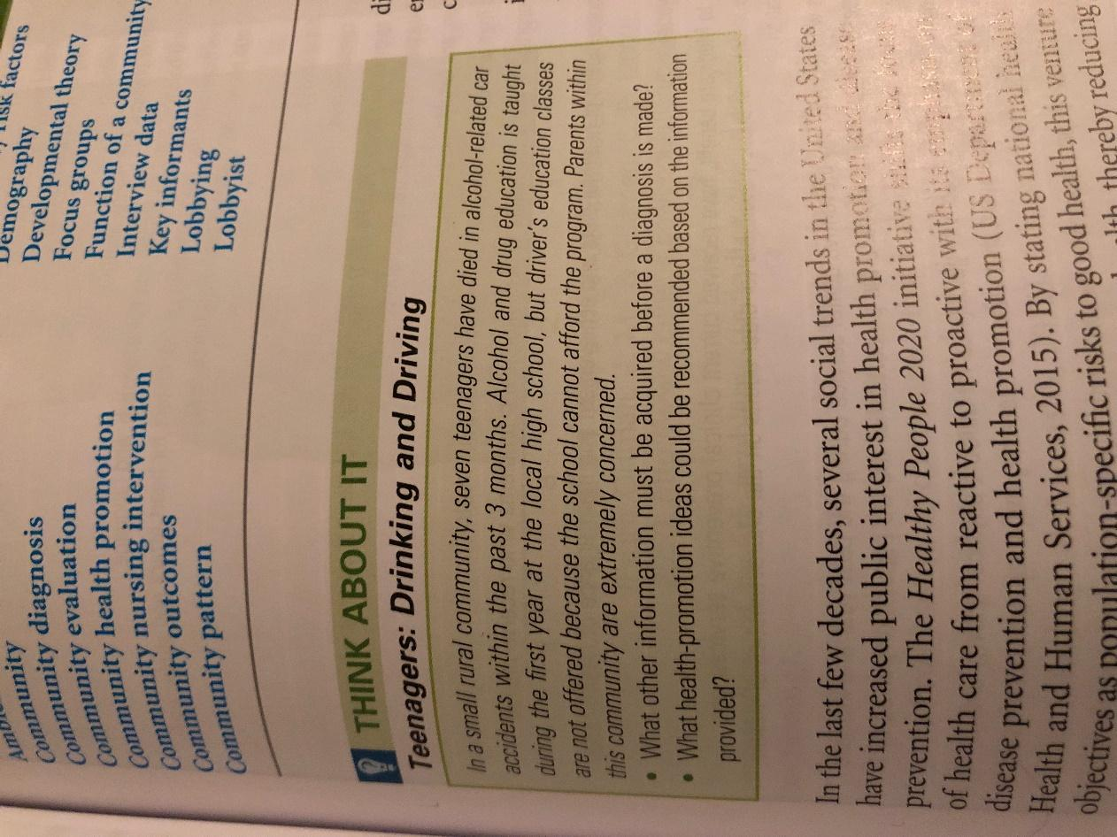
- What health promotion programs would you recommend based on
the information provided?
- What individuals in the community would you want to involve?
- Can you think of non-health related community members that would be good
additions to a group assembled to help with interventions in this situation?

Alcohol and drug-related programs strive to prevent people from consuming one. Nevertheless, education and awareness are the main tools in addressing these issues to help students and young adults to consume less in order to reduce the harm it inflicts to themselves as well as to other people. Meanwhile, schools can implement Alcohol Moderation Management Programs that would serve as a month-long period of the student’s abstinence to drinking and will result to that person’s exploration to other alternative activities other than drinking or drugs (Hester, Delaney, & Campbell, 2011). Moreover, these programs would be possible with the help of the community, most especially, the institutions and healthcare professionals in eradicating the consumption of alcohol in schools. Thus, these individuals would act as the mediating factor that would help students and young adults to know the consequences of alcohol and drug abuse to their bodies.

Aside from the individuals mentioned, non-health community members would also play role in making Alcohol Moderation Management Programs possible. It would potentially involve students, parents, institutions, and business industries in raising awareness on the issue. For instance, businesses tend to develop core objectives that will help improve the community’s quality of life, which is referred to as their corporate social responsibility. By the means of this, it would be more attainable for the institution to incorporate programs with the aid of business leaders’ budget and components that will help in assisting health programs (Kindig, Isham, & Siemering, 2013).

References

Hester, R. K., Delaney, H. D., & Campbell, W. (2011). ModerateDrinking.com and moderation management: Outcomes of a randomized clinical trial with non-dependent problem drinkers. Journal of Consulting and Clinical Psychology, 79(2), 215-224.

Kindig, D. A., Isham, G. J., & Siemering, K. Q. (2013). The business role in improving health: Beyond social responsibility. Discussion Paper, Institute of Medicine. Retrieved from https://nam.edu/wp-content/uploads/2015/06/TheBusinessRole.pdf

- You are asked to provide health teaching to a group of preschool children. Select a teaching topic and share –
a] teaching principles,
b] domains of learning used and why,and
c] suggested teaching activities.
Examples for teaching topics include “brushing teeth” “look both ways before crossing the street
[safety]” [See Edelman & Mandle (textbook) on page 234 -Table 10-2 - Domains of Learning, Teaching Strategies, and Examples of Desired Outcomes Related to a Behavior Change.]
Table 10-2

By the time a child enters first grade, some of their habits are already formed. It is crucial to ensure the creation of healthful habits, so health education during the year of preschool is necessary. Health education should start when a child is as young as to years (McCORMICK, 1976). Preschoolers should be developing the attention span, where they sit still and listen to their parents or teachers to for more than a minute. It is an important skill for them to become more focus on what should be learned. Fruit and Vegetable Identification is the best health teaching topic for a group of preschool children.

Identifying fruit and vegetable as acting and it is included in the psychomotor domain of learning. Demonstration, practice, and mental imaging are the teaching strategies that could apply to the group of preschool children (Edelman & Mandle, 2018). If I were a teacher, I would demonstrate the performance of skills linked to the behavioral change. First, I would demonstrate to them the activities that we will be going to do, including the name of that fruit/vegetable, benefits they can get from it, and how and where it can be grown. I would gather a variety of fruits and vegetables in a wide container and then allow each student to put on a blindfold. Students should touch, smell, or taste the item in order to recognize the fruit or vegetable. After doing it, the students must place that item in a basket and try to guess what fruit or vegetable it is. In the end, I would assess the students how they listened to me earlier and ask them how that fruit/vegetable is grown, where it can be grown, and the health benefits of eating them.

References

Edelman, C. & Mandle, C. L. (2018). Health promotion throughout the lifespan (9th ed). USA: Mosby.

McCORMICK, P. A. U. L. A. (1976). Health education for preschoolers. Educational Horizons, 55(1), 28-30.

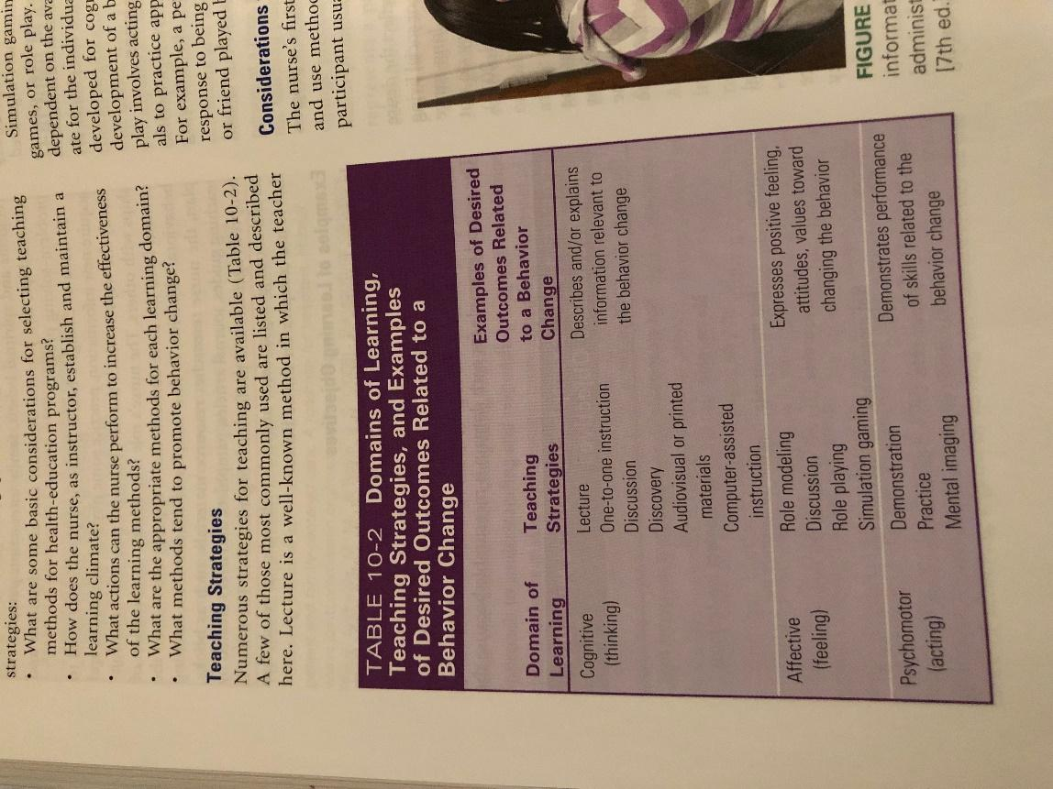

Scenario:
- A mother of three (3) children ages 4, 7 and 11 works part-time and goes to school to study for a Master’s degree full time. Her husband works away from the home during the week and is home on weekends. She reports that she is stressed to the point that it affects her sleep at night. After reviewing chapter 13 in See Edelman & Mandle (textbook) what stress management interventions would you recommend? Please elaborate.(Stress management interventions that are in chapter 13 are Developing self-awareness, nutrition: healthy diet, physical activity, sleep hygiene, cognitive-behavioral restructuring, affirmations, assertive communication, social support, empathy, healthy pleasures, spiritual practice, clarifying values and beliefs, setting realistic goals, humor, and engaging in pleasurable activities)

Stress is defined as the physical, psychological, or social effect of life’s pressured events, which often interrupts and disturbs an individual’s homeostasis. Once observed, it would affect an individual that is likely to develop negative health indicators. From the identified stress management interventions, I believe that assertive communication and social support would help the mother overcome her stressors. For instance, Edelman and Mandle (2018) asserted that poor communication is the biggest stress at the household. The mother, being unable to express or talk about her needs to her husband, creates stress. Developing assertive communication to the husband will allow the mother to speak up for herself but in a thoughtful manner. Given that she works part-time and attends masteral, it is important that she and her husband discuss the possible schedule for them to cope up with the needs of their children and their personal interests as well. If assertive communication takes place, it is more likely that the mother would guide her in defining the problem of the household.

Meanwhile, social support is also needed in this situation. Similar to assertive communication, it would also help the mother, as well as her husband, to find alternatives to attend to the needs of their family and interests. Social support is needed for venting bad emotions and reducing pain at the same time. It can also be added that social support would reduce stress and eliminate symptoms of depression. After all, sharing problems with your partner is the most apprehended way to deal with the issue by discussing the potential solutions and its results.

Reference

Edelman, C. & Mandle, C. L. (2018). Health promotion throughout the lifespan (9th ed). USA: Mosby.

Holistic Interventions
- A person has seen a physician for migraine headaches and no origin for the pain can be found after multiple tests are done. Review the many holistic interventions shared in chapter 14 [See Edelman & Mandle (textbook).] Which one of these interventions may be beneficial for the person with migraine headaches? Share why you chose this intervention.

According to Lundy and Janes (2009), a holistic approach to health care assess, prevents, treats, and promotes wellness. Aside from that, it can help meet the objectives of Health People 2020. The holistic practitioners seek to support the natural healing system of the person. The interventions used in holistic health care practice are considered as alternative practices into some conventional practices of health care; these also help Americans live longer (Edelman & Mandle, 2018).

There are many holistic interventions discussed in the textbook, these include bodywork, prayer, energy work, music therapy, aromatherapy, meditation, imagery, the movement arts of yoga, qi gong, and massage. These interventions provide a beneficial supplement to current nursing theory. One of these interventions may be beneficial for the person with migraine headaches, but aromatherapy and massage could be considered (Edelman & Mandle, 2018). To use aromatherapy, a person can use natural plant extracts that promote health. Essential oil therapy such as few drops of lavender oil, peppermint, and ginger, can apply to the part that aches for the fast headache relief. Massage is also a holistic intervention that can cure a migraine. I suggest that a person should massage her/his neck and temples by rubbing it to improve blood flow and soothe tension headaches. I chose these interventions since it is the right treatment that can help the person to feel better. It is crucial for us to take care of ourselves. Always remember that well all need a little relaxation and time for ourselves to prevent from that health conditions.

References

Edelman, C. & Mandle, C. L. (2018). Health promotion throughout the lifespan (9th ed). USA: Mosby.

Lundy, K. S., & Janes, S. (2009). Community health nursing. Jones & Bartlett Learning.

